Chapter 5, Problem 74

Find i_{o} in the op amp circuit of Fig. 5.100.

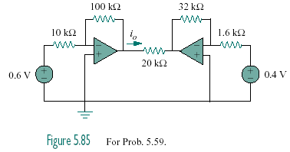
0.9 V
0.6 V

Figure 5.100
For Prob. 5.74.

